# MPProxy Server Install

System Requirements

Mac OS X Server 10.6 or higher

4 Gigs or RAM

100 Gig or available disk space

Firewall Info

TCP Ports Needed 80, 2600

Install

1. MPProxySrv.pkg
2. Edit siteconfig.xml  
   “/Library/MacPatch/Server/conf/etc/siteconfig.xml”
   1. You’ll need info from MP server
      1. primaryServer
      2. seedKey
   2. Optional Config
      1. mailto
         1. enable, set to 0=off, 1=on
         2. email, email address to send results
      2. ip
         1. allow, a ip or partial ip to match against  
            (Allow Force Replication by calling MPProxy.cfm)
3. Run mpproxyConfig.sh  
   “/Library/MacPatch/Server/conf/scripts/mpproxyConfig.sh”
   1. Note: the script has to be run with sudo
4. Login to “Server Admin.app” and validate the SSL certificate for the “_MPWSLSite2600” web site.  
     
   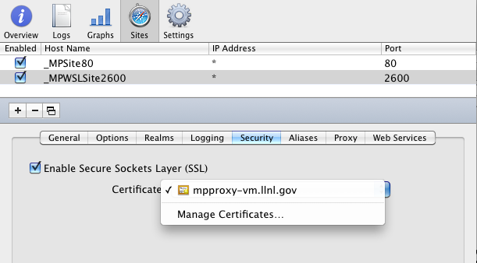

Additional Info

The MacPatch proxy server does not have an admin console all configurations are done via the siteconfig.xml.

View trusted certs

keytool -list -keystore /Library/MacPatch/Server/conf/jsseCerts/jssecacerts -storepass changeit

Support Info

Log file: mpproxy.log